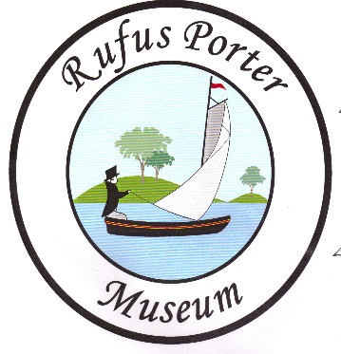
^{The} Rufus Porter Museum
The Rufus Porter Museum celebrates the life and times of a remarkably creative American genius

Vendor Registration Form

Name: _______________________________________________________________________

Address:______________________________________________________________________

City:______________________________ State:_______ Zip:__________________________

Phone:______________________ Email:__________________________________________

Please refer to the map on the back of registration form for space numbers. Spots can be reserved in advance on a first come, first serve basis. Indicate the top three spots you would prefer and we will let you know what spot is available in your confirmation email. Some spots have access to electricity for an additional fee of $5.00. The locations on outside wall have access to outlets.

10x10 Space ($35.00) (2) 10x10 Spaces ($50.00)

Need Electricity: Yes No

Top 3 Spaces:

_______________ _______________ _______________

Total Amount: ________________
Please send payment to the Rufus Porter Museum at PO Box 544, Bridgton ME 04009
22
13
12
11
10
Exit
9
8
6
7
5
1*
4
2*
3*

24
23

Entrance
Stage
GYM
14
18
19
15
16
20
21
17
Exit
Entrance

